Foreign Minister Retno: ASEAN and EU Must Cooperate for Mutual Benefit

Jakarta, 13 July 2023 - Minister of Foreign Affairs Retno Marsudi has called on ASEAN and the European Union to continue fostering inclusive cooperation in various fields. The statement was made at the ASEAN-European Union Post Ministerial Conference (PMC) meeting on Thursday (13/7) in Jakarta.

Foreign Minister Retno said that ASEAN - EU cooperation is being tested by the global situation which is facing enormous challenges. To navigate these dynamics, ASEAN and the EU must continue to enhance inclusive cooperation.

In this regard, Foreign Minister Retno conveyed two important aspects. First, maintaining an inclusive regional architecture. Retno emphasised that ASEAN has invested heavily in constructing an inclusive regional architecture. She hoped the European Union would share the same view on the inclusive collaboration paradigm.

"We hope the European Union can apply the paradigm of inclusive collaboration. This is the only way to maintain peace, stability, and prosperity," Retno said.

The second issue discussed was enhancing mutually beneficial cooperation. Retno said that ASEAN and the European Union have great potential aplenty. Both organisations are each other’s third largest trading partner. Both organisations also have integrated economies with 450 million consumers in the EU and 650 million consumers in ASEAN. She emphasised that this potential should not be limited by trade barrier policies.

"This potential should not be limited by trade barrier policies such as the European Union Deforestation Regulation (EUDR) and the European Union Enforcement Regulation (EUER)," Retno said.

Therefore, both parties must find a joint solution through ASEAN-EU mechanisms such as the Joint Working Group on Palm Oil. In addition, ASEAN and the EU must also strengthen strategic partnerships based on the principles of mutual respect and mutual benefit.

"Indonesia hopes that ASEAN-EU strategic cooperation can be strengthened based on the principles of mutual respect and mutual benefit," Retno said.

The meeting discussed the 45-year ASEAN-EU partnership. ASEAN countries appreciated a number of achievements including the successful ASEAN-EU Summit in Brussels, maritime cooperation in the Indo-Pacific framework, increased trade and investment, cooperation on energy transition, socio-culture, and health. The meeting also underlined the importance of resolving the South China Sea issue, concerns over the situation in Ukraine, and the Korean Peninsula.

However, a number of ASEAN countries expressed concern over the implementation of the EU Deforestation Regulation, which is considered to hinder the entry of ASEAN countries' products into the EU market. The meeting also encouraged the completion of the ASEAN-EU Free Trade Agreement.

Meanwhile, High Representative for Foreign Affairs and Security Policy/Vice-President of the Commission (HRVP) Joseph Borell recognised ASEAN's role as a key global player in this century, especially amid ongoing global rivalries and crises. The EU also supports the importance of respecting international law, especially regarding the Ukraine and South China Sea issues. Furthermore, HRVP Borell also emphasised support for ASEAN's approach to resolving the Myanmar issue.

***

For further information, please contact the following:

Director for Information and Media of the Ministry of Foreign Affairs - Hartyo Harkomoyo (+62811831899)

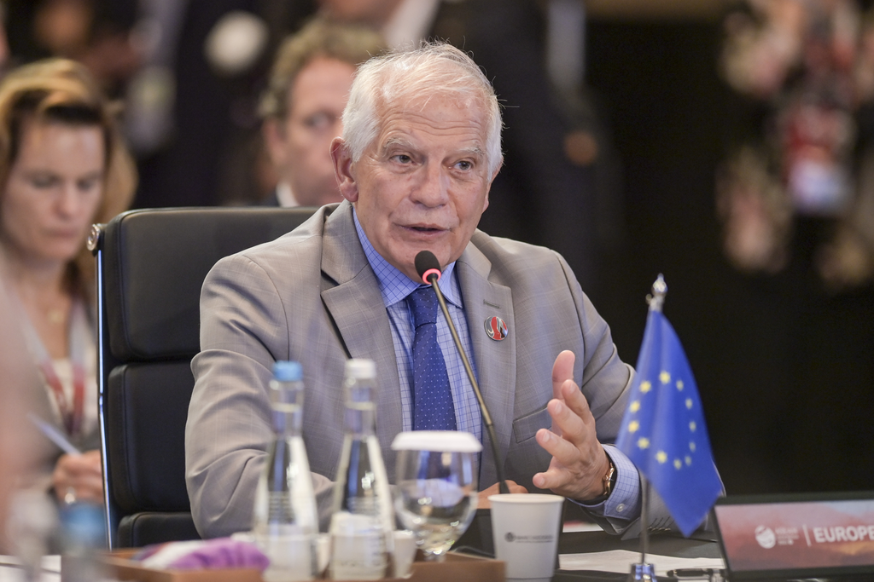

Indonesia has called on ASEAN and the European Union to continue fostering inclusive cooperation in various fields at the ASEAN-European Union Post Ministerial Conference (PMC) meeting in Jakarta (13/7) (Photo: Ministry of Foreign Affairs of Indonesia).

